SUMMERVILLE CREDIT UNION · CONSOLIDATED MEMBER GUIDE · CSUM-04 of 30
Account Detail — All Account Types

Module: nFinia Digital Banking > Accounts > [Account]
Sources: Summerville Reports Series A (36 docs) + Series B (25 docs) | Features: nFinia Documentation Features Spreadsheet
01 PRODUCT SUMMARY

Each account type in nFinia has a dedicated Account Detail page providing the full operational view of that account. The Checking Account Detail is the most-visited page for most members — it shows the real-time balance, complete transaction history, and provides direct access to all account services. Savings and dividends accounts add dividend rate information and earning summaries.
Money Market accounts show tiered rate details alongside transaction history. Certificate of Deposit accounts display maturity date, interest rate, term, and renewal options. Loan accounts show the outstanding principal, next payment due, payment history, and provide direct access to the loan payment workflow. Line of Credit accounts display the credit limit, drawn amount, available credit, and transaction history including draw and repayment records.
All account detail pages follow a consistent layout: balance summary at top, transaction history in the main panel, and related actions/links in the side panel or at the bottom. This consistency reduces the learning curve for members managing multiple account types.

At a Glance

Attribute | Detail
Account Types Covered | Checking, Savings/Dividends, Money Market, CD, Loan, Line of Credit
Common Features | Balance summary, Transaction history, Related Links, Transfer shortcuts
Checking-Specific | Account/routing number, Stop Payment, Check Reorder
Loan-Specific | Next payment due, Principal balance, Payment history, Pay Now shortcut
CD-Specific | Maturity date, Interest rate, Term, Renewal election
Related Reports | CSUM-03 (Account Overview), CSUM-14 (Loan Payments), CSUM-05 (eDocuments)

02 KEY USE CASES

Use Case | Who Uses It | What They Do | Business Value
Daily Balance Monitoring | Members checking account status | Open account detail for real-time balance and recent activity | Instant financial status without contacting CU
Stop Payment Request | Members stopping an issued check | Open checking detail > Related Links > Stop Payment | Prevents a check from clearing without branch visit
Loan Payment Tracking | Members monitoring loan status | Open loan account detail to see principal, interest, and payment history | Full loan amortization visibility in one screen
CD Maturity Election | Members with maturing certificates | Open CD account detail > Renewal Options before maturity date | Self-service CD renewal election without branch appointment
Round Up to Savings | Members building savings automatically | Enable Round Up feature in account settings to round up debit transactions | Passive savings accumulation from everyday spending

03 STEP-BY-STEP GUIDE

Navigation: Dashboard > Accounts > tap any account tile.
Step 1 — Start from Dashboard
The member begins at the Dashboard after logging in. The Dashboard displays all account balances, upcoming payments, quick-action tiles, and the top navigation bar with links to Accounts, Move Money, and More.
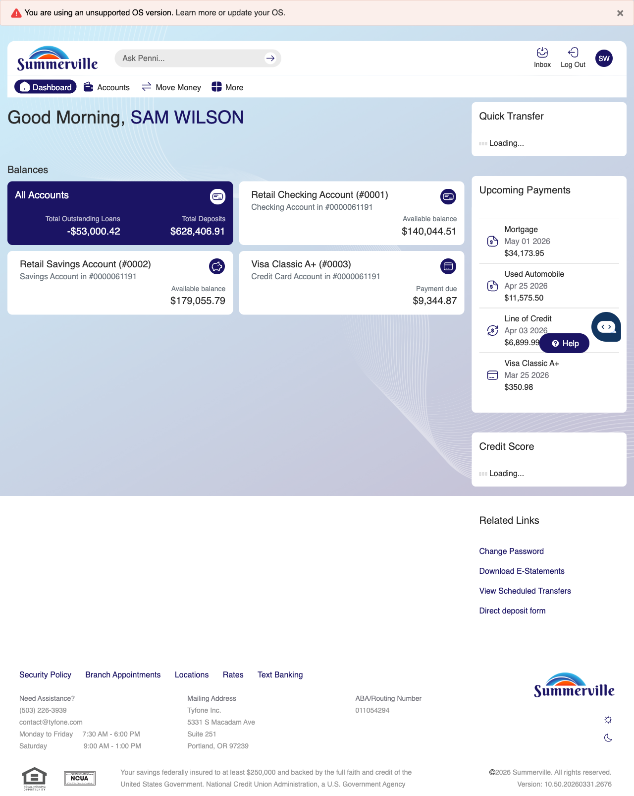
Step 1: Start from Dashboard

Step 2 — Open the More Menu
The member clicks ‘More’ in the top navigation bar. The More options panel expands to show additional features: Check Deposit, User ID and Password, eDocuments, Account Alerts, General Alerts, Password, Forms, One-Time Passcode, Skip A Pay, Do-Not-Disturb, Manage Devices, My Insights, Alert Settings, Recent Activities, and Card Services.
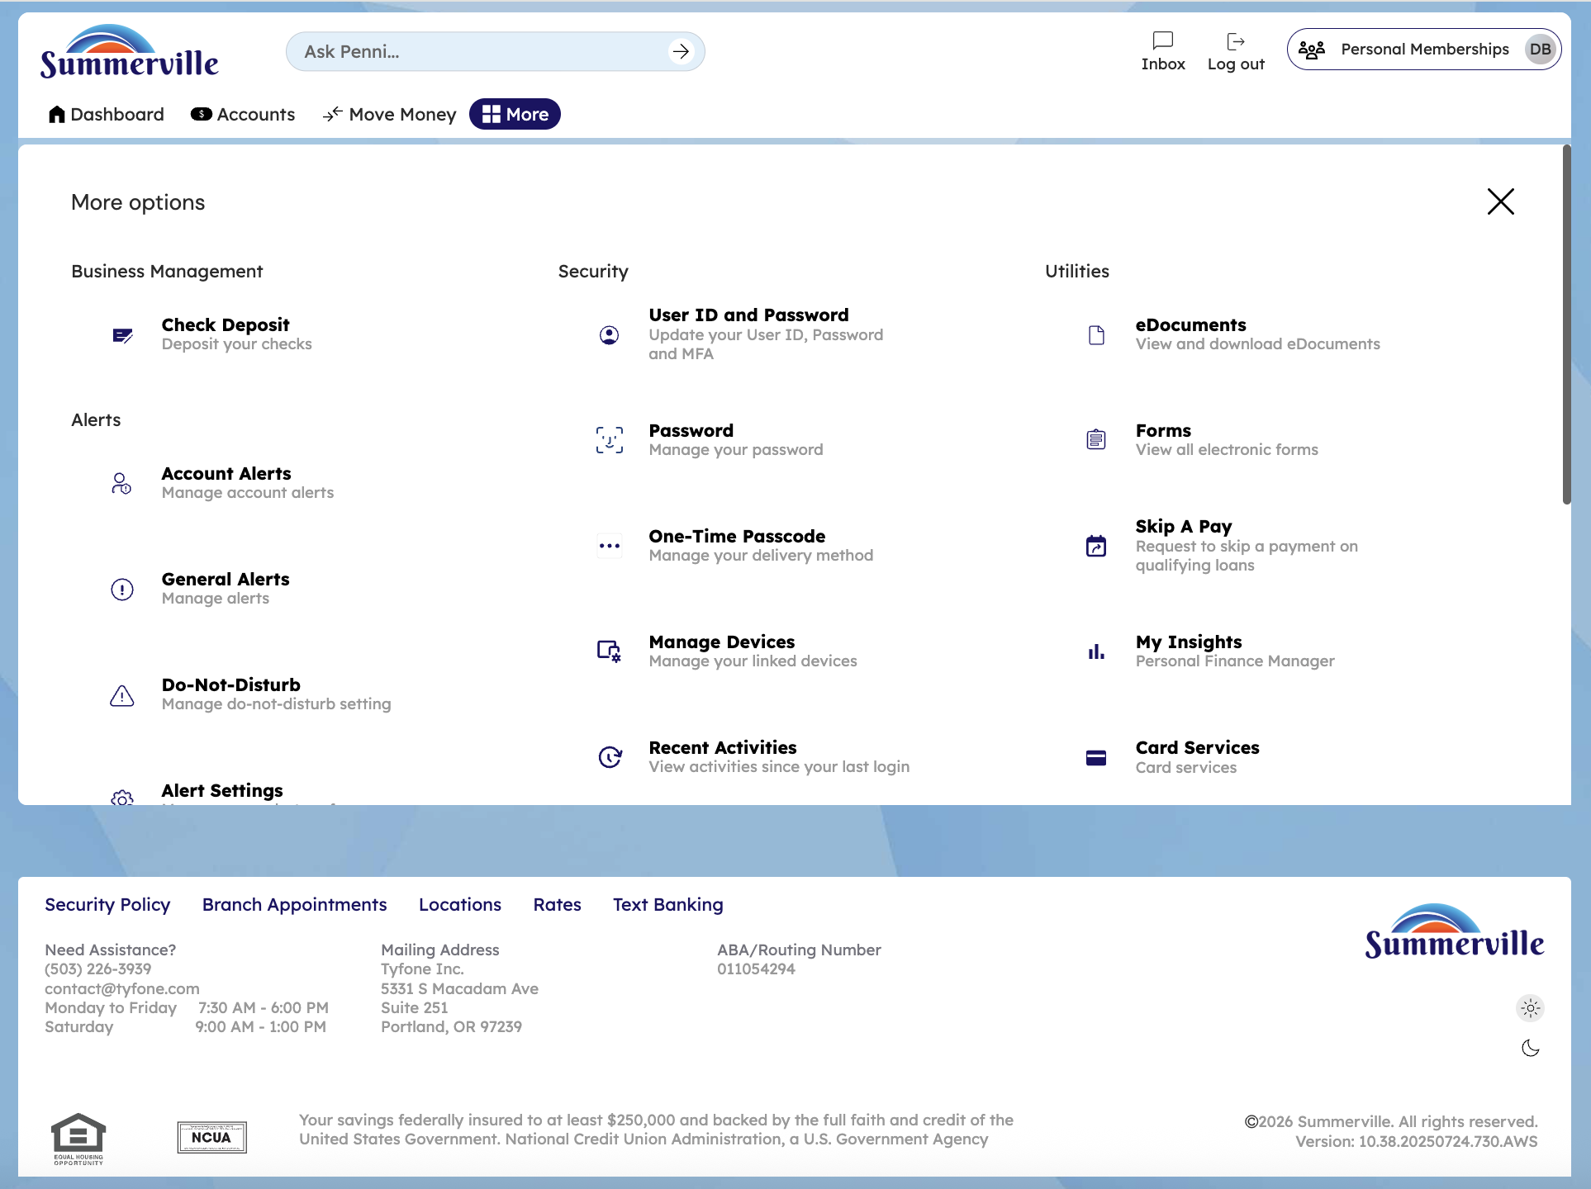
Step 2: More Menu

Step 3 — Navigate from Dashboard to Account Detail
The Account Overview page is shown in membership view with checking and savings accounts displaying their balances. A promotional banner and the Quick Transfer section are visible on the right side.
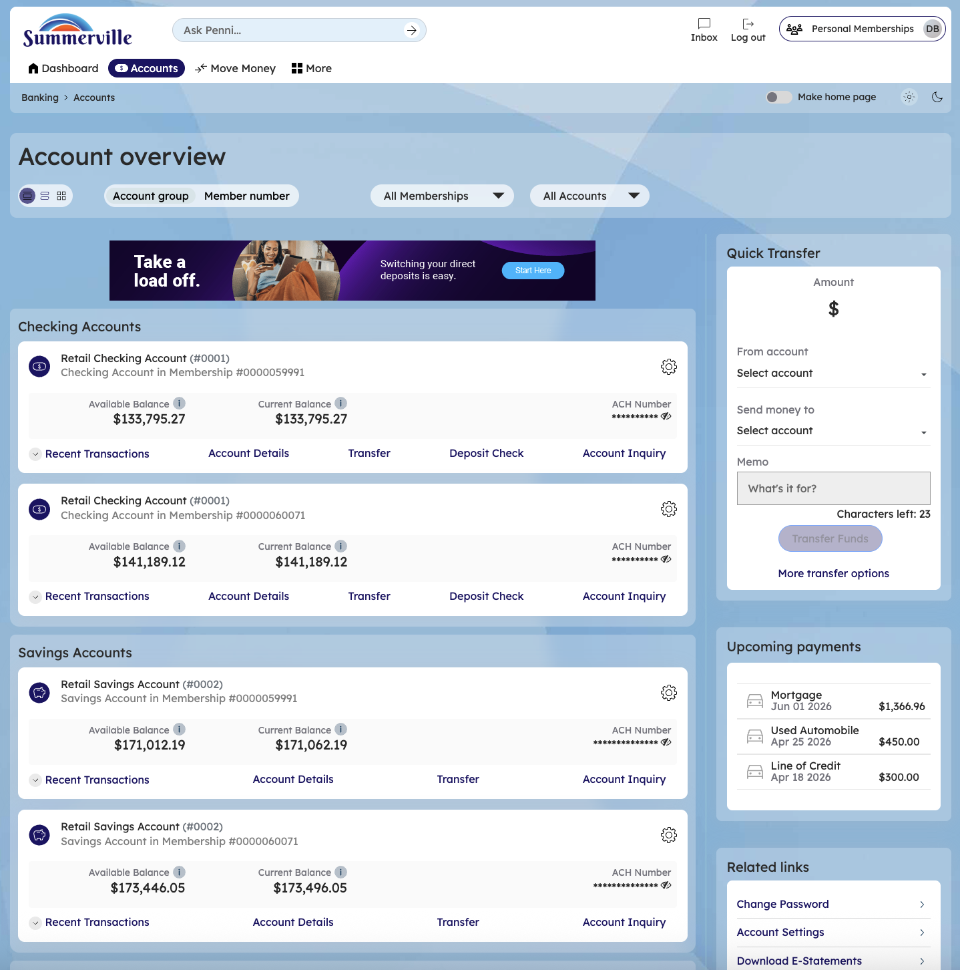
Step 3: Navigate from Dashboard to Account Detail

Step 4 — View Checking Account Balance & History
The Retail Checking Account detail page displays the current balance, YTD dividend amounts, and a filterable transaction history. A Quick Transfer widget is available in the right sidebar.
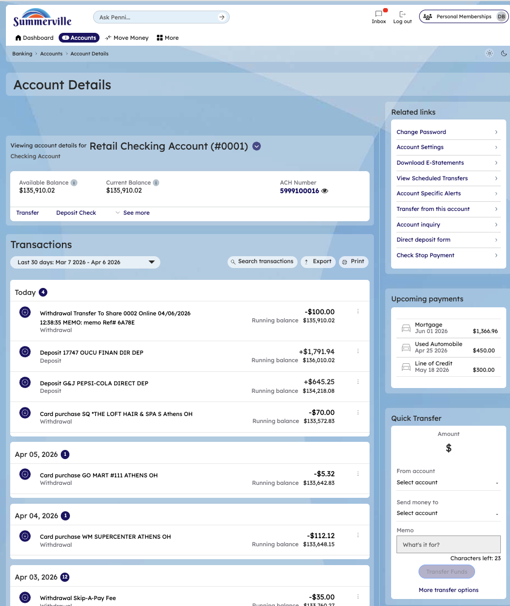
Step 4: View Checking Account Balance & History

Step 5 —Check Recent Transactions
Click on account details and check recent transaction and search recent transactions and shows the date
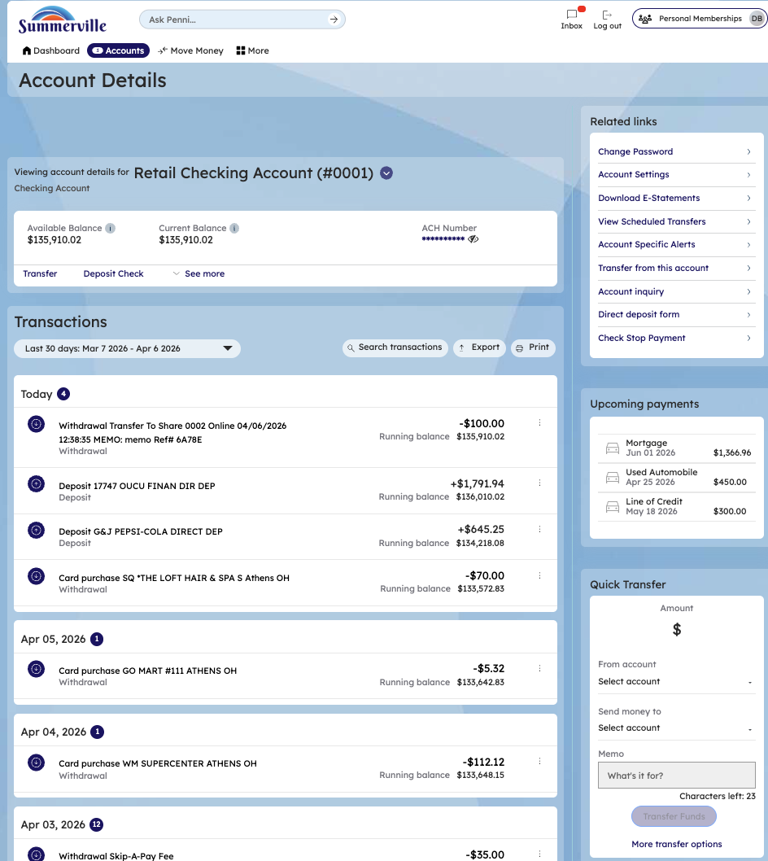
Step 6 —search transactions
Check recent withdrawals using transaction search,also you have the option to export the transaction,and varoius filters on the right hand side
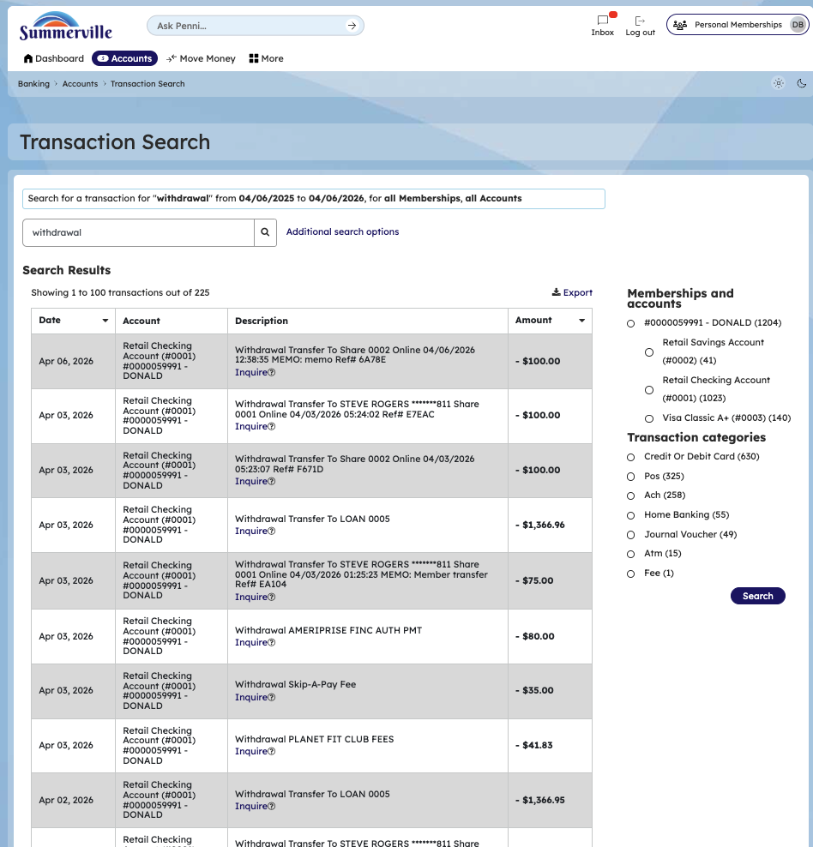
Step 7 —export transaction
Export transactions,you can select format and the date range from and to of the trasactions
